E-CONTENT

MJMC, SEM-II, PAPER : CC-7
Topic : Different Types Of Photography

Date : 24-01-2020, TIME : 12.00 P.M.-1.00 P.M.

PREPARED BY : AMIT KUMAR

Different Types Of Photography

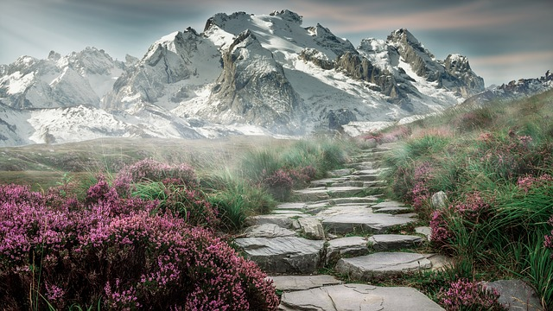

There are many types and Genres of Photography. People tend to specialize or lean towards one or two types for many reasons. Even within the dozens of categories, there are even more subcategories. This article is about the 25 most popular types, and some sample photos for each type, and finally some related links from our site.
You may prefer watching the three videos below, they summarize the rest of the post. If not, and you prefer continue reading, just skip the videos.

- Landscape photography
This is one of the most popular types of photography, Shooting photographs of natural environments, known most commonly as landscape photography, is one of the most popular and fun ways to get started in the art of taking pictures. The Wikipedia site defined the landscape photography as capturing the presence of nature but it can also focus on man-made features or disturbances of landscapes. While it may seem simple to snap a couple of photos of a mountain or a hillside, it can be a bit more complicated than point and shoot.
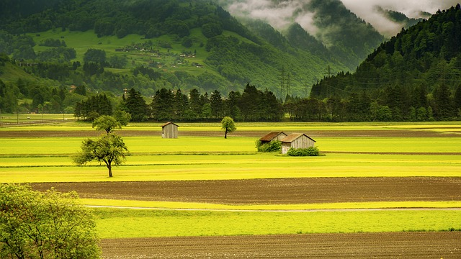
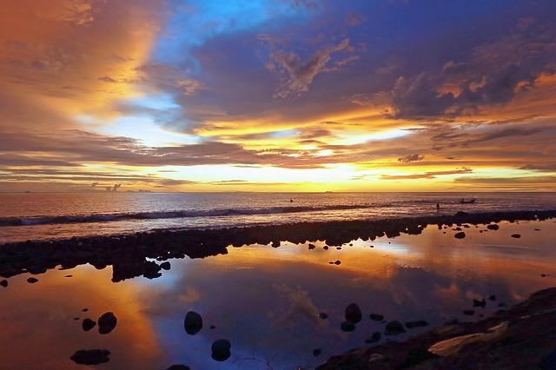
- Portrait photography
Capturing peoples’ moods and expressions is an intriguing subject for photographers. They can be close-up images, body portraits etc. Typically the face is the focus of this type of photography. While taking a portrait, the photographer should ensure that the subject’s face is sharp and focused, especially his or her eyes. The subject’s pose should also be flattering, and try to capture a person’s natural expressions.
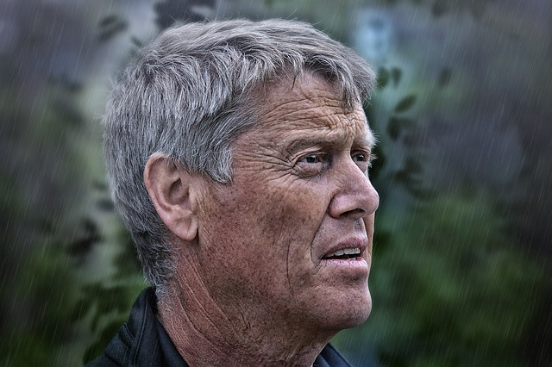
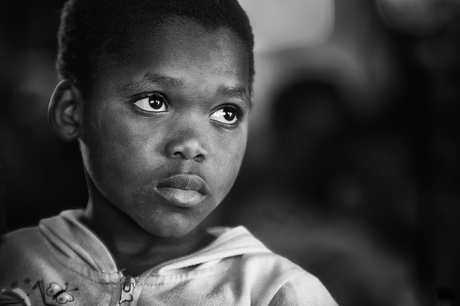

- Wildlife photography
Wildlife photography is a genre of photography concerned with documenting various forms of wildlife in their natural habitat. It is one of the more challenging forms of photography. Wildlife photographers generally need good field craft skills. For example, some animals are difficult to approach and thus knowledge of the animal’s behavior is needed in order to be able to predict its actions.
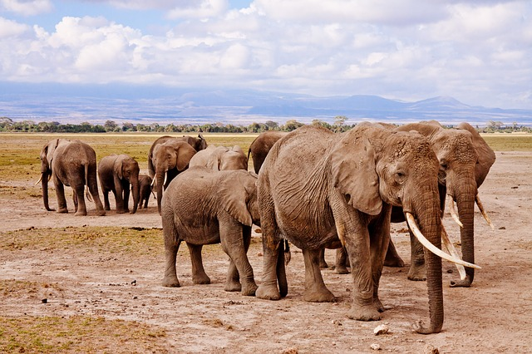
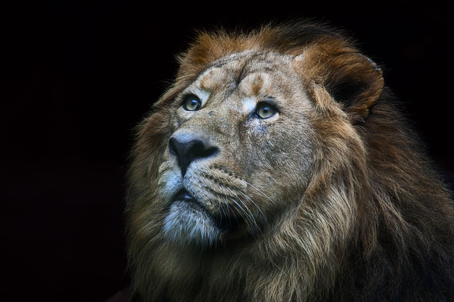

- Fashion Photography
Fashion photography is a genre of photography which is devoted to displaying clothing and other fashion items. Fashion photography is most often conducted for advertisements or fashion magazines such as Vogue, Vanity Fair, or Elle.
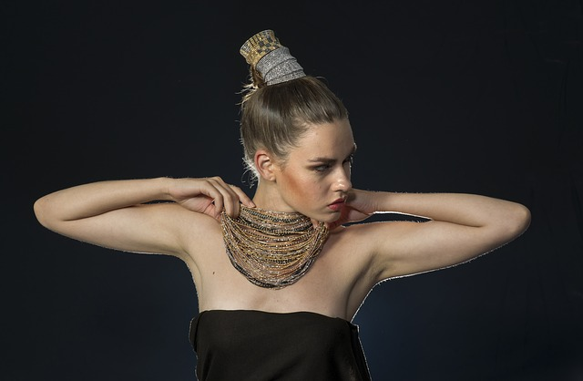

- Nature Photography
Nature Photography doesn’t involve only plants or trees; it involves the natural scenery as seen through the photographer’s eyes. It can be landscapes, hills, waterfalls, wildlife or anything that can be captured outdoors.
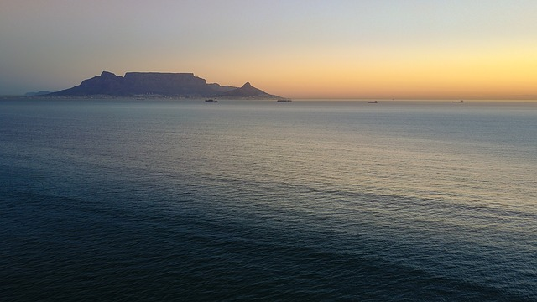
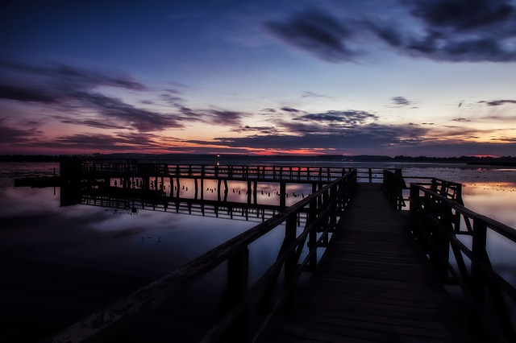

- Architectural photography
The architectural photography has an almost endless range of possibilities, there are chances to capture some of the world’s most significant monuments at one end, whilst at the other end of the scale, and there are chances to capture someone’s humble home or living space. Shooting old and historical buildings is an interesting part of the architectural photography, also the interior of the building is another wonderful part of architectural photography; they can offer you a big chance to capture some amazing photos.
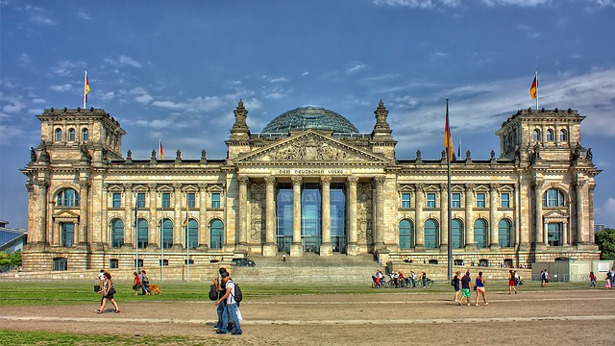
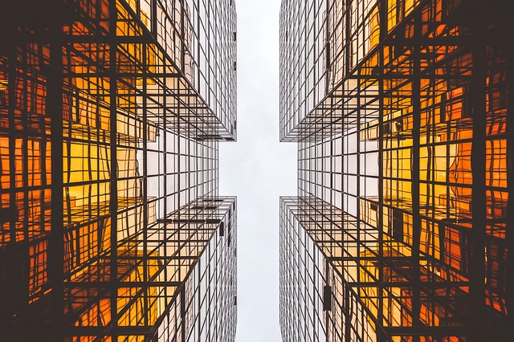

- Sports Photography
Sports photography refers to the genre of photography that covers all types of sports. In the majority of cases, professional sports photography is a branch of photojournalism. The main application of professional sports photography is for editorial purposes; dedicated sports photographers usually work for newspapers, major wire agencies or dedicated sports magazines. However, sports photography is also used for advertising purposes both to build a brand and as well as to promote a sport in a way that cannot be accomplished by editorial means.
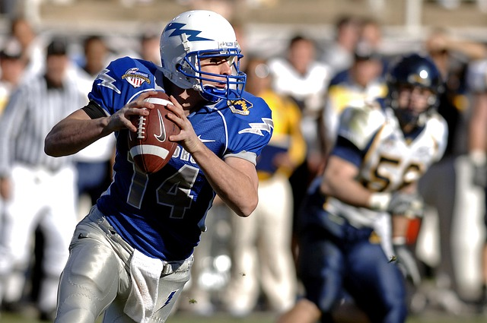
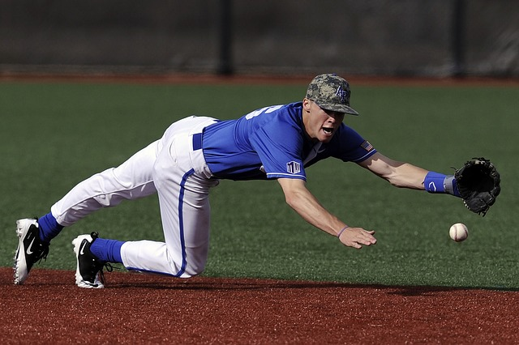

- Night photography
Night photography refers to photographs taken outdoors between dusk and dawn. You don’t need to travel a lot to search for exotic places to take photos, you can still get stunning photographs of some subjects, places, building, city streets etc., they look ordinary and may be boring at daylight, but they turn into fantastic scenes at night. Night photographers generally have a choice between using artificial light and using a long exposure, exposing the scene for seconds, minutes, and even hours in order to give the digital sensor enough time to capture the suitable amount of light.
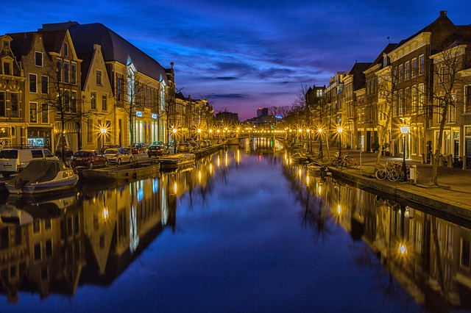
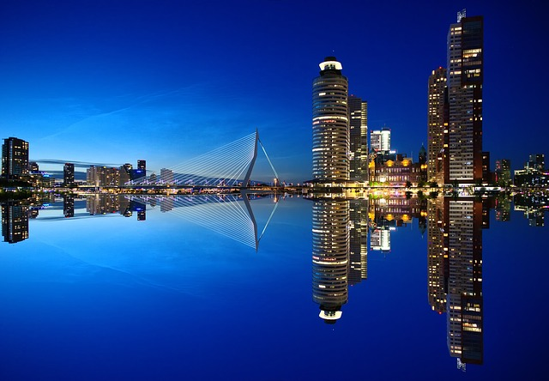
- Wedding photography
Wedding photography is the photography of activities relating to weddings. It encompasses photographs of the couple before marriage (for announcements, portrait displays, or thank you cards) as well as coverage of the wedding and reception. A decent wedding retains the most ravishing memories in one’s lifetime. Everyone envisions that their wedding day will be astonishing, the cake, the music, the flowers, the guest, the venue but what makes these memories live forever is the artistic photographs.
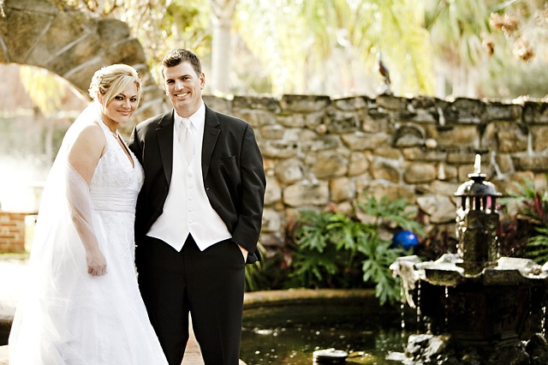
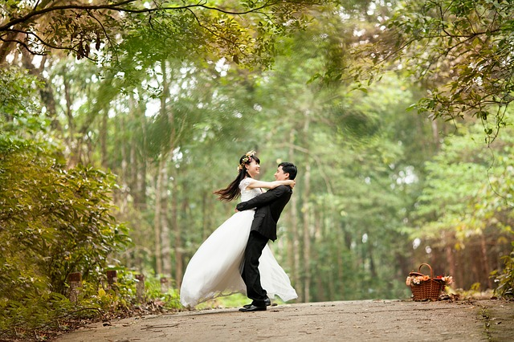
- Macro photography
Macro photography is extreme close-up photography, usually of very small subjects and living organisms like insects, flowers, Jewelry, even a water droplet in which the size of the subject in the photograph is fully filled the photo frame. Macro photography brings out the minute details of the chosen subject. Things that is not normally visible to the human eyes looks amazing in macro photography.
